**LAB 5.1: UNDERSTANDING, CREATING, AND SIMULATING MULTIPLE VLANS IN A SINGLE SWITCH**

**OBJECTIVE:**

* To understand and create multiple VLANS in a single switch

**TOOLS USED:**

* Packet Tracer

**BACKGROUND:**

VLAN, which stands for Virtual Local Area Network, is a customized network created by grouping one or more local area networks together. VLANs are used to segregate workstations and limit access to specific groups of users. By dividing the network into isolated VLANs, organizations can enhance security, improve network management, and optimize bandwidth allocation. This lab aims to provide hands-on experience in configuring and simulating multiple VLANs within a single switch environment.

**TOPOLOGY:**

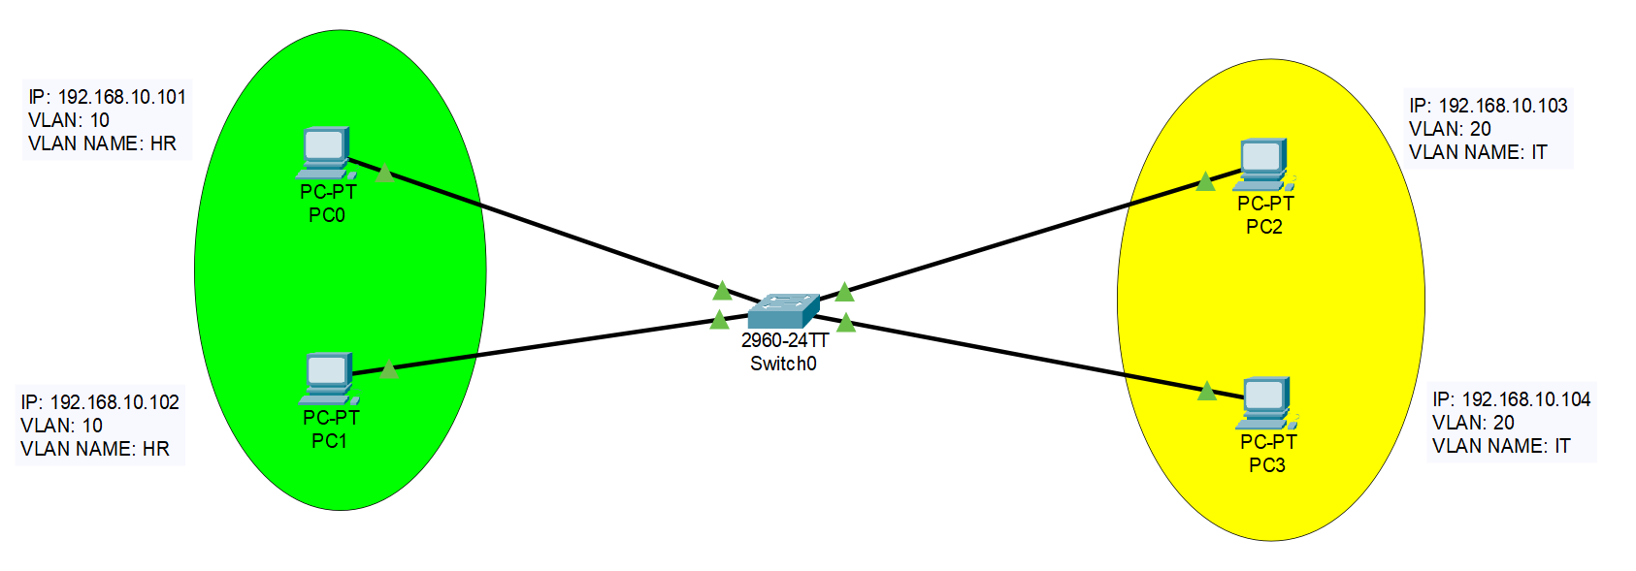

**IP Addressing Plan:**

|  |  |  |  |  |  |
| --- | --- | --- | --- | --- | --- |
| Device | Interface | IP Address | Subnet Mask | VLAN | Gateway |
| PC0 | NIC | 192.168.10.101 | 255.255.255.0 | 10/HR |  |
| PC1 | NIC | 192.168.10.102 | 255.255.255.0 | 10/HR |  |
| PC2 | NIC | 192.168.10.103 | 255.255.255.0 | 20/IT |  |
| PC3 | NIC | 192.168.10.104 | 255.255.255.0 | 20/IT |  |

**PROCEDURE:**

1. Create a topology and assign an IP Address as shown above.
2. Now create two VLANs in a switch as:
   * Click on switch icon > config> VLAN Database
   * Then enter VLAN name and number and then click on the add.

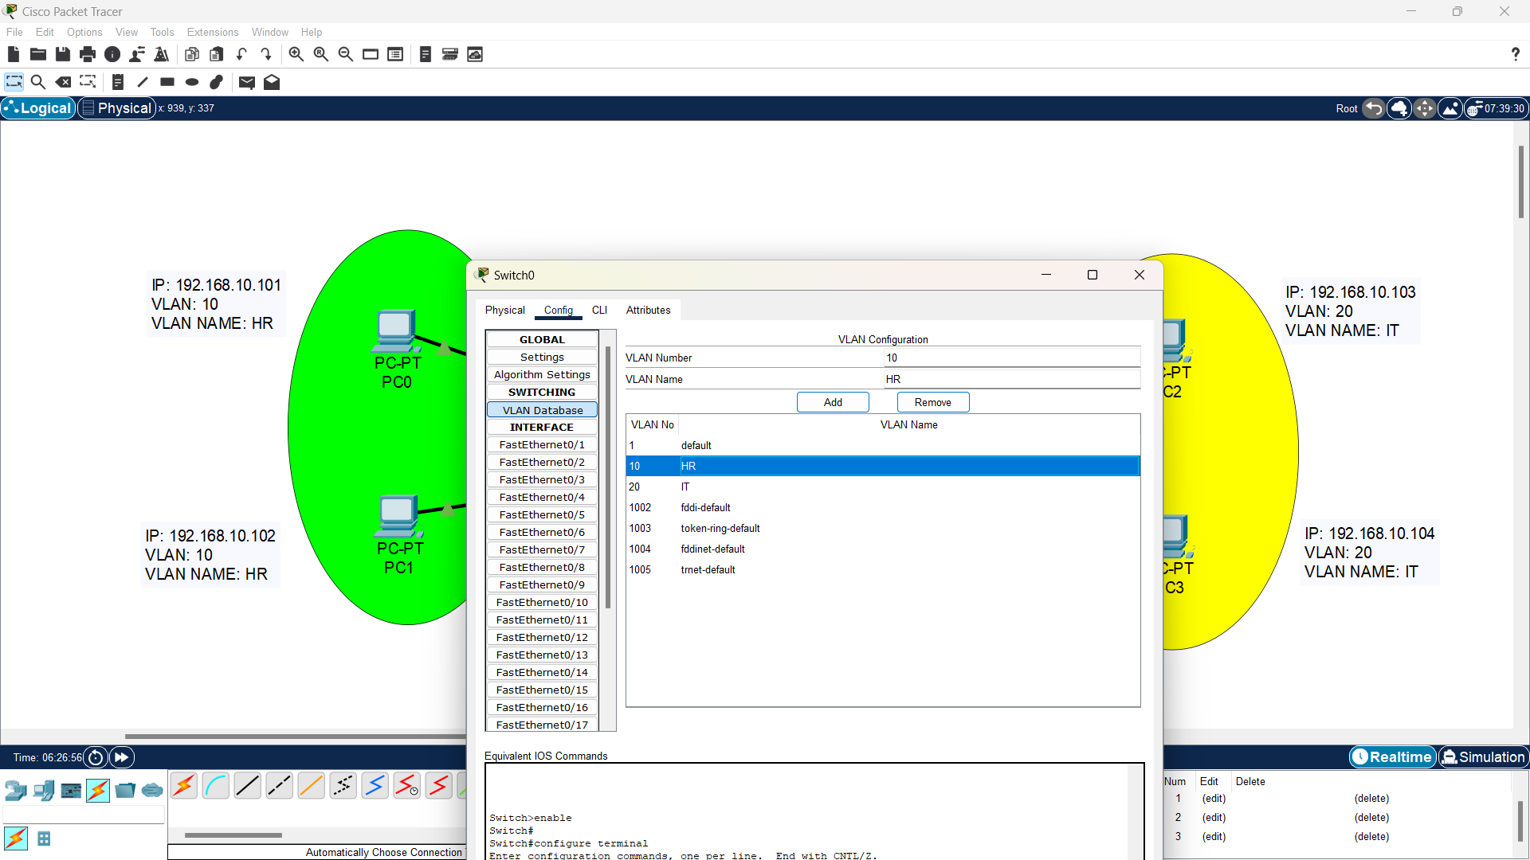

1. Assign the PC connected interface of switch into the VLAN, you want to assign

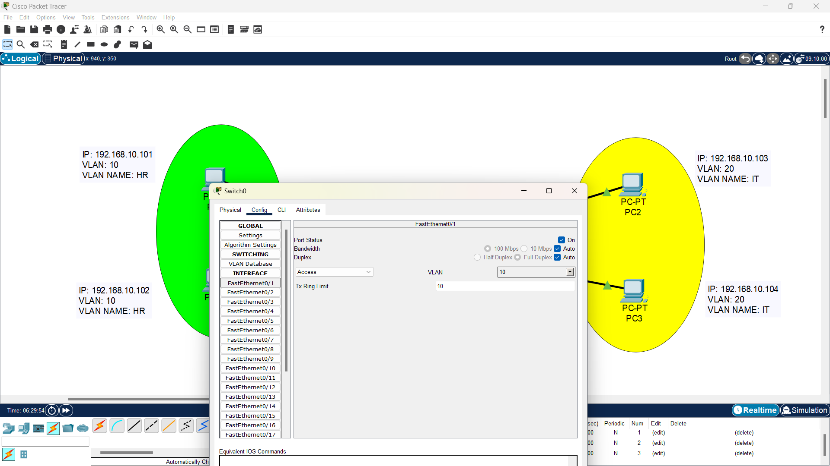

**VERIFICATION:**

1. Ping PC as:

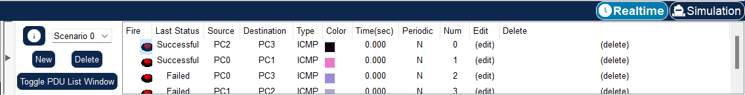

1. Finally view the details of the VLANs created within a switch

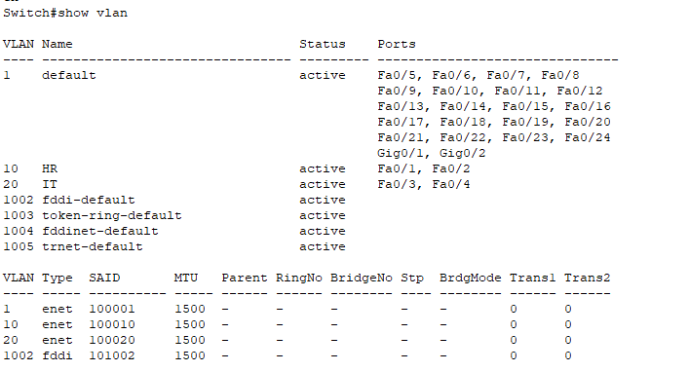

**CONCLUSION:**

In conclusion, Understanding, Creating, and Simulating Multiple VLANs in a Single Switch successfully demonstrated the creation and simulation of multiple VLANs within a LAN. By segregating devices into different VLANs, we were able to observe that PCs within the same VLAN can communicate with each other, while communication between PCs in different VLANs was restricted. This functionality effectively divides the broadcast domains and minimizes broadcast traffic within the LAN. Through this lab, we gained a better understanding of VLANs and their role in enhancing network security and performance.

LAB 5.2: VLAN

UNDERSTANDING, CREATING, AND SIMULATINGMULTIPLE VLANS DISTRIBUTED IN MULTIPLE SWITCH

OBJECTIVE:

* To understand and create multiple VLANS distributed in multiple switches.

TOOLS USED:

* Packet Tracer

BACKGROUND:

A Virtual Local Area Network (VLAN) is a network technology that allows the creation of multiple logical networks within a single physical network infrastructure. It provides a way to segment a network into smaller, isolated groups based on various criteria, such as departments, functions, or security requirements. The purpose of VLANs is to limit access to specific groups of users by dividing workstations into different isolated VLANs. This segmentation enables network administrators to effectively manage and control network traffic, enhance security, and optimize network performance.

TOPOLOGY:

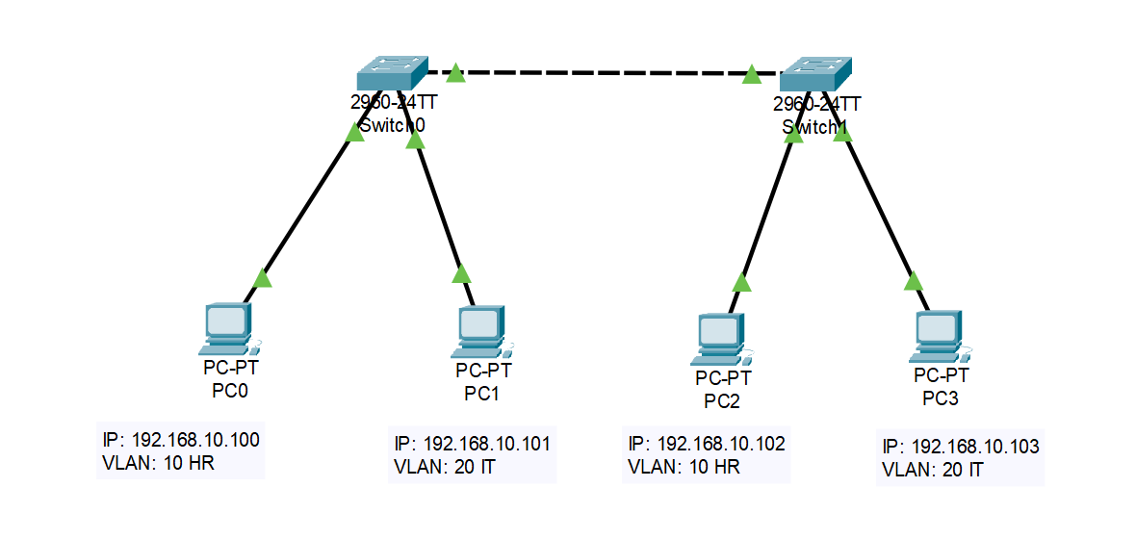

IP ADDRESSING PLAN:

|  |  |  |  |  |  |
| --- | --- | --- | --- | --- | --- |
| Device | Interface | IP Address | Subnet Mask | VLAN | Gateway |
| PC0 |  | 192.168.10.100 | 255.255.255.0 | 10/HR |  |
| PC1 |  | 192.168.10.101 | 255.255.255.0 | 20/IT |  |
| PC2 |  | 192.168.10.102 | 255.255.255.0 | 10/HR |  |
| PC3 |  | 192.168.10.103 | 255.255.255.0 | 20/IT |  |

PROCEDURE:

1. Create the topology and assign the IP address as shown in IP addressing plan above.
2. Create two VLANs in each switch as



